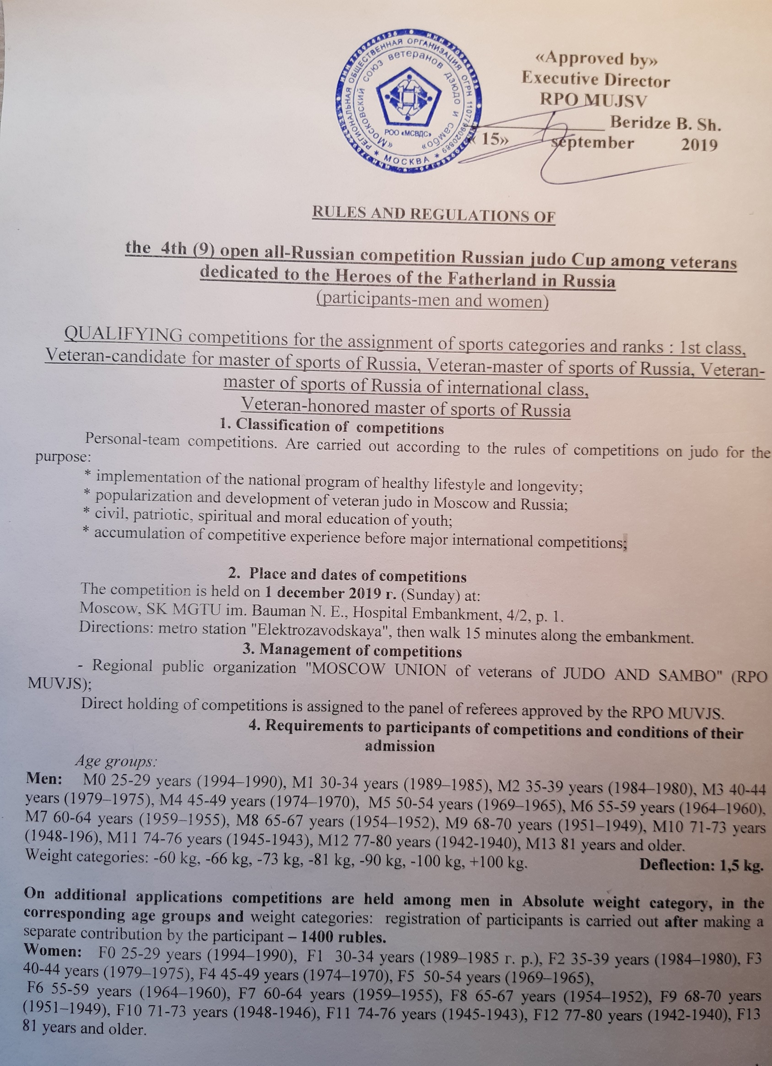
Weight categories: -48 kg, -52 kg, -57 kg, -63 kg, -70 kg, -78 kg, +78 kg. Deflection: 1,5 kg.

On additional applications competitions are held among men in Absolute weight category, in the corresponding age groups and weight categories: registration of participants is carried out after making a separate contribution by the participant – 1200 rubles.
Athletes must be in their age group on the competition day.

5. Competition program
1 december 2019 – day of submission of documents and applications from competitors.
10.00-11.00 – weigh-in of participants of competitions;
11.00-11.20 - work of the Mandate Commission, meeting of the jury;
11.20 – 11.40 – «draw»;
11.40 – 11.55 General meeting of team representatives, coaches;
12.00-16.00 | Opening ceremony, preliminary, semifinal fights, final fights and rewarding of prize-winners of competitions
Competitions are held on THREE tatami at the same time,
one kimono of any color.

6. Determination of winners and awards
Competitions are held according to the Olympic system with repechage from semi-finalists – 9 participants and more on a mixed system – 5-8 participants, round robin– 4 participants and less. Champions and prize-winners are defined according to the rules of competitions on judo. Fight time - 3 minutes (for participants older than 60 years – 2.5 minutes). In each weight category and age group the first, second and two third places are played. If less than 2 applications are submitted for one weight category, by the decision of the panel of judges, it may be combined with the corresponding weight category of one of the nearest age groups.
7. Awards
The participants who took the first, second and two third places in personal competitions, in each weight category, are awarded with diplomas, medals and memorable prizes. If in weight only two athletes, they carry out three fights to a ratio of victories-2:0 or 2: 1. Two "victories", for all weight categories of competition is a necessary condition for the full set of points for awarding sports ranks "the veteran – the master of sports of Russia" (30 points), "Veteran – master of sports of Russia of international class" (100 points), "Veteran honored master of sports of Russia" (150 points),
According to the results of personal competitions, including in the Absolute weight category, the teams of regions and sports clubs that became winners of the competition are determined. Teams of Moscow and Moscow region, who took the first, second and third place are awarded with diplomas and Cups. Teams of cities and regions of Russia, who took the first, second and third place are awarded with diplomas and Cups.
Additionally there can be set special prizes for rewarding athletes, coaches, judges from RPO MUJSV, sponsors, organizations and individuals.
8. Costs and Fees
Costs related to the sending participants, heads of delegations, coaches in the delegation to the competition (travel and insurance) are provided by the sending organization or the athletes themselves. Costs on carrying out competitions provides RPO MUJSV. The competitions are held by RPO MUJSV. Voluntary unpaid participation fee of the competition is 1700 (one thousand seven hundred) rubles in connection with the next increase in rent of a tatami.
Economy class accommodation (from 400 to 1000 rubles) you can book a bed in the hostel on the Internet – by typing: HOSTEL IN MOSCOW CHEAP or 7 mest.com, тел.+7 (495) 972-32-32; HOSTEL ON PAVELETSKAYA oe dom197.ru, тел.+7 (901) 578-15-15; ВСЕ ОБЩЕЖИТИЯ.РФ, +7 (495) 135-27-17.

9. Applications
Preliminary applications (without seals) are submitted to RPO MUJSV until 23 november 2019 inclusive, by phone 8-905-581-99-37 - Беридзе Борис Шалвович, or to his e-mail: 02041953@mail.ru; Official applications from the teams (see appendix No. 1) are submitted to the mandate Commission at the official weigh-in.
Athlete – veteran participating in the competition independently (not in teams) for the weigh-in and credentials Committee declares a personal note (without Application) with the mandatory provision of medical certificate of his (her) admission to participation in competitions on judo among veterans.
Competitors must have a passport of a citizen of their country or a document on its legal registration in Russia.
For military personnel-military ID or ID card.
The athlete is personally responsible for the authenticity of the documents submitted to the mandate Commission.
10. Security provision and Etiquette.
- direct medical assistance to competitors is provided by a doctor;
- participants of competitions independently carry out insurance of their health;
- participants strictly abide by the provisions of this Regulations and Rules judo competition;
- violation of generally accepted norms and rules of conduct in public places is prohibited;
- it is forbidden to smoke and drink alcohol in the competition venues.
Violators are subject to a measure of influence determined by the Chief justice or the head of RPO MUJSV.
Addition: when required, upon the written request of the athlete, perhaps the direction of writing at his place of work on personal invitation of the athlete to participate in competitions.
This Provision is an official challenge to the competition.
Telephone inquiries: 8-905-581-99-37

Appendix № 1

APPLICATION

For participation in ____________________________ _________from _______________________________
name of competition name of organization

City ____________________________, Federal district_________________________________
_________________________________________________________________________________________

№ | Full name | Date of birth | Weight | Age group | Category, rank |  |  |  | Phone,  e-mail | Coach full name | Doctor`s visa

Team representative Signature Full name

Doctor Allowed _____ people Signature Full name

«_____» _____________ 201___

Applications are accepted only in printed form.

Athletes with an application or a medical certificate without the signature and seal of a doctor are not allowed to compete.

